Day17

DIY

Q1.How To Enable S3Intelligent-Tiering Archive Access And Deep Archive Access tiers

Background:

To get the lowest storage cost on data that can be accessed in minutes to hours, you can activate one or both of the archive access tiers by creating a bucket,prefix,or object tag level configuration using the AWS Management Console, AWS CLI,Or Amazon S3 API.

Solution-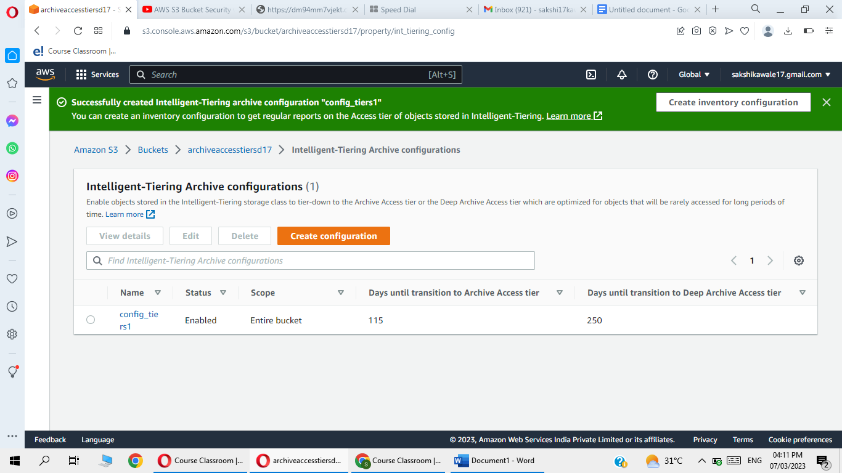

Q2.How to restore objects from the S3 Intelligent-Tiering Archive Access and Deep Archive Access tiers

Objective:

To access objects in the S3 Intelligent

-Tiering Archive Access and Deep Archive Access tiers, you must initiate the restore request and wait until the object is moved into the Frequent Access tier

Background:

When youre store an object from theArchive Accesstier or Deep Archive Accesstier,the object moves back into the Frequent Accesstier.Afterward, if the object isn't accessed for 30 consecutive days, it automatically moves into the Infrequent Access tier. Then, it moves into the Archive Accesstier after a minimum of 90consecutive days of no access.It moves into the Deep Archive Accesstier after a minimum of180consecutivedays ofnoaccess.TherearenoretrievalchargesinS3Intelligent-Tiering.Standardand Bulk data retrievals and restore requests are free of charge for both the Archive Access and Deep Archive Access tiers. Subsequent restore requests called on archived objects that have already been restored are billed as a GET request.

Solution-

-Go to aws management console

-Search and open S3

-Choose the bucket that contains the object that you want to resotre

-Select objects

-Go to actions

-click restore

The object will be restore.